

Python Project – Calculator GUI

High-Level Design (HLD)

Internship Project

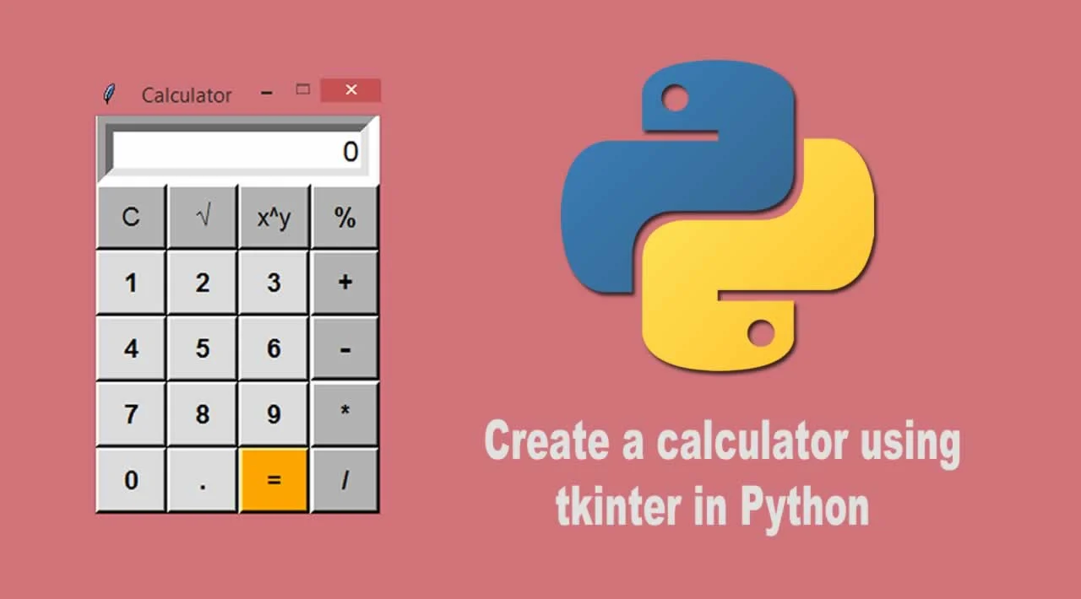

By Rahul Sharma

Contents

Contents ………………………………………………………………………2 Abstract…………………………………………………………………… ….3

1. Introduction……………………………………………………………….. 4

1.1 Why this High-Level Design Document?........................................... …...4

1.2 Scope……………………………………………………………… ……..4

2. General Description……………………………………………… ………...5

2.1 Product Perspective & Problem Statement………………………… …….5

2.2 Tools Used………………………………………………………… …......5

3. Design Detail…………………………………………………………… ….6

3.1 Functional Architecture……………………………………………… …..6

3.2 Optimization………………………………………………………… .......6

4. Deployment…………………………………………………………………6

ABSTRACT

When North Carolina first began to allow calculators on state tests, many elementary teachers (including me) were shocked! What? Kids need to develop basic computation skills before they are allowed to use calculators!

Then we got a look at the new state math test. Holy moly! The test was divided into two parts, a calculator-inactive section, and a much longer calculator-active part that was made up entirely of word problems! I realized that if my 5th graders had to work out every answer by hand, they would never finish the test! I also realized that it wouldn’t be fair to hand out calculators for the first time on test day. In short, I needed a new game plan…. one that involved calculators.

In today’s time, calculators in schools are just as widely used as computers are. Since its invention nearly forty years ago, the electronic calculator has evolved from the machine that could only perform simple four-function operations ( addition, subtraction, multiplication, division) into one that can now also execute highly technical algebraic symbolic manipulations instantly and accurately. Each new generation of calculators builds on the previous one, with heightened speed and more advanced capabilities.

1. . INTRODUCTION

1.1Why this High-Level Design Document?

The purpose of this High-Level Design (HLD) document is to add the necessary detail to the current project description to represent a suitable model for coding. This document is also intended to help detect contradictions before coding and can be used as a reference manual for how the modules interact at a high level.

The HLD will:

• Present all the design aspects and define them in detail

• Describe the user interface being implemented

• Describe the hardware and software interfaces

• Describe the performance requirements

• Include design features and the architecture of the project

• List and describe the non-functional attributes, like:

● Security

● Reliability

● Maintainability

● Portability

● Reusability

● Application compatibility

● Resource utilization

● Serviceability

1.2 Scope

The HLD documentation presents the structure of the system, such as the database architecture, application architecture (layers), application flow (Navigation), and technology, Architecture. The HLD uses non-technical to mildly-technical terms, which should be understandable to the administrators of the system.

2. General Description

2.1 Product Perspective & Problem Statement

Problem Statement:- A user-friendly Calculator name ‘CalCi’

The purpose of a calculator is **to do correct calculations and to do so efficiently**. A calculator should relieve the user of the need to do mental operations and of the need to rely on paper, as far as possible.

2.2 Tools used

Jupyter Notebook and Python Programming Language with Tkinter packages are used to build the whole framework.

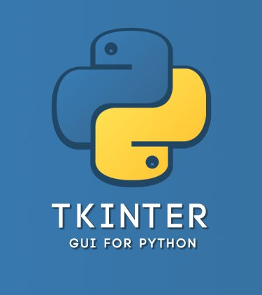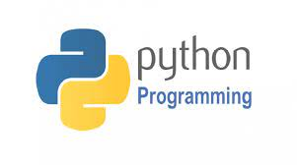

3. Design Details

Here I will be making a simple calculator in which we can perform basic arithmetic operations like addition, subtraction, multiplication, or division.

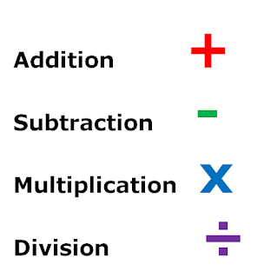

4. Deployment

With the use of Python programming skills & Tkinter package, I make a GUI of a Calculator Which will help to add, subtract, Multiply and divide.

